Hill Lane Surgery
Newsletter
June 2018

Thank you all very much for confirming, that you wish to continue to be a member of our Patient Participation Group. We really do value your feedback, and would be very grateful for any suggestions or comments (both good and bad).

Paula Smith
Practice Manager
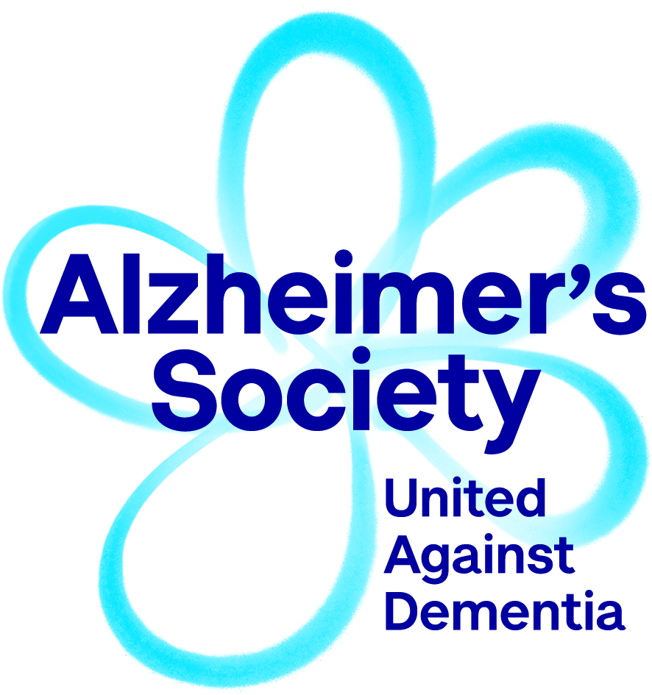

We get it. We will do it.
We are United.
At Alzheimer’s Society we offer support and information for anyone affected by dementia.
Dementia Support Service: In Southampton we offer a Dementia Support Service for those with a diagnosis of dementia, and their carers. This is delivered by Dementia Support Workers who work one-to-one with anyone who is affected by dementia. We can offer information to people who are worried about their memory, and ongoing support to people affected by dementia. This can be face to face, over the phone or in writing.
Singing for the Brain: This is a very friendly and fun group for those with a diagnosis of dementia, and their carers. We start with a cup of tea/coffee, biscuits and chat, followed by an hour of singing. It runs every first and third Thursday of the month. 2 – 3:30pm at Thornhill Baptist Church, Thornhill Park Road, Southampton, SO18 5TR.
National Dementia Helpline: Our friendly and helpful advisors are there to answer any questions you may have about dementia or memory problems; or just to talk. 0300 222 11 22.
“Talking Point”: Our online community. This is our online forum where you can share experiences with others affected by dementia. You can access it through our website www.alzheimers.org.uk.
Information and publications on dementia: We offer a huge breadth of information in the form of factsheets, and publications (Dementia Guide, Memory Handbook), which can be accessed in different languages, audio/visual/British Sign Language or easy to read. This can be accessed through our website, or you are welcome to call us at the local office to request any information you require.
Getting in touch: If you would like to speak to one of Dementia Support Workers, or to discuss any of our other services, please don’t hesitate to get in contact. Local office telephone number:

023 8061 0159
Email: southampton@alzheimers.org.uk

_______________________________

We’re on TARGET for better services
TARGET is a scheme that brings our city’s GPs, Practice Nurses and Health Care Assistants together every two months to learn new skills, hear about new treatments and share good practice. We think it will mean better services all round – that’s what we’re aiming for! It means Hill Lane Surgery will need to close for one afternoon every two months but we will ensure that medical care will be available when you need it.
The surgery will therefore be closed on the following afternoons, but the Out of Hours service (which can be accessed by calling 111) will cover:

Wednesday 11th July 2018
Wednesday 19th September 2018
Thursday 8th November 2018
Thursday 17th January 2019
Wednesday 13th March 2019

______________________________

GP online services

GP online services allow you to access a range of services via your computer or mobile. Once you have signed up, you will be able to:
- book or cancel appointments online with a GP
- renew or order repeat prescriptions online
- view parts of your GP health record, including information about medication, allergies, vaccinations, previous illnesses and test results
The service is free. Everyone who is registered with a GP can have access to their practice's online services. For more details, speak to Reception and they will give you details on how to join up.
You will have to provide photo ID and proof of address. If you do not have any ID then either a member of staff will have to confirm your identity or you may have to answer questions about personal information in your GP record. Once you have signed up, you will receive a letter with your unique username and password and a link to where you can log in
__________________________________

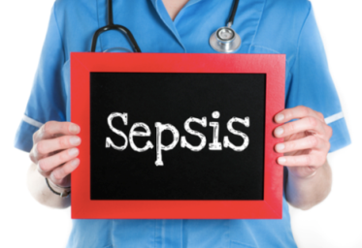

SEPSIS - a rare but serious complication of an infection.

Sepsis symptoms in children under five

Go straight to A&E or call 999 if your child has any of these symptoms:

- looks mottled, bluish or pale
- is very lethargic or difficult to wake
- feels abnormally cold to touch
- is breathing very fast
- has a rash that does not fade when you press it
- has a fit or convulsion

Get medical advice urgently from NHS 111
If your child has any of the symptoms listed below, is getting worse or is sicker than you'd expect (even if their temperature falls), trust your instincts and seek medical advice urgently from NHS 111.

Temperature
- temperature over 38C in babies under three months
- temperature over 39C in babies aged three to six months
- any high temperature in a child who cannot be encouraged to show interest in anything
- low temperature (below 36C – check three times in a 10-minute period)
Breathing
- finding it much harder to breathe than normal – looks like hard work
- making "grunting" noises with every breath
- can't say more than a few words at once (for older children who normally talk)
- breathing that obviously "pauses"

Toilet/nappies
- not had a wee or wet nappy for 12 hours

Eating and drinking
- new baby under one month old with no interest in feeding
- not drinking for more than eight hours (when awake)
- bile-stained (green), bloody or black vomit/sick

Activity and body
- soft spot on a baby's head is bulging
- eyes look "sunken"
- child cannot be encouraged to show interest in anything
- baby is floppy
- weak, "whining" or continuous crying in a younger child
- older child who's confused
- not responding or very irritable
- stiff neck, especially when trying to look up and down

If your child has any of these symptoms, is getting worse or is sicker than you'd expect (even if their temperature falls), trust your instincts and seek medical advice urgently from NHS 111.

Sepsis symptoms in older children and adults
Early symptoms of sepsis may include:
- a high temperature (fever) or low body temperature
- chills and shivering
- a fast heartbeat
- fast breathing
In some cases, symptoms of more severe sepsis or septic shock (when your blood pressure drops to a dangerously low level) develop soon after.
These can include:
- feeling dizzy or faint
- a change in mental state – such as confusion or disorientation
- diarrhoea
- nausea and vomiting
- slurred speech
- severe muscle pain
- severe breathlessness
- less urine production than normal – for example, not urinating for a day
- cold, clammy and pale or mottled skin
- loss of consciousness

When to get medical help
Seek medical advice urgently from NHS 111 if you've recently had an infection or injury and you have possible early signs of sepsis.If sepsis is suspected, you'll usually be referred to hospital for further diagnosis and treatment. Severe sepsis and septic shock are medical emergencies. If you think you or someone in your care has one of these conditions, go straight to A&E or call 999.

__________________________________

Prescription charges
Regulations have been laid before Parliament to increase certain National Health Service charges in England from 1 April 2018. In the 2015 Spending Review, the government committed to support the Five Year Forward View with £10 billion investment in real terms by 2020 to 2021 to fund frontline NHS services. Alongside this, the government expects the NHS to deliver £22 billion of efficiency savings to secure the best value from NHS resources and Primary Care must play its part. This year, therefore, parliament has increased the prescription charge by 20 pence from £8.60 to £8.80 for each medicine or appliance dispensed. To ensure that those with the greatest need, and who are not already exempt from the charge, are protected they have frozen the cost of the prescription prepayment certificates (PPC) for another year. Charges for wigs and fabric supports will also be increased in line with inflation.

Prescription charges

Single charge: £8.80
- 3 month PPC (no change): £29.10
- 12 month PPC (no change): £104.00

Wigs and fabric supports

- Surgical bra: £28.85
- Abdominal or spinal support: £43.60
- Stock modacrylic wig: £71.25
- Partial human hair wig: £188.70
- Full bespoke human hair wig: £275.95
____________________________________

Screening in adults
Screening is a way of identifying apparently healthy people who may have an increased risk of a particular condition. The NHS offers a range of screening tests to different sections of the population.
The aim is to offer screening to the people who are most likely to benefit from it.

Cervical Cancer Screening is offered to women every 3 years between the ages of 25 and 49 years, and every 5 years between the ages of 50 and 64 years. If you are not up to date with Cervical Cancer Screening please do contact the Surgery and make an appointment with the Practice Nurse to have it carried out. If you have had a Cervical Cancer Screen abroad within the last 5 years you would still be eligible for an NHS Screen

Bowel Cancer Screening is offered to all men and women every 2 years between the ages of 60 and 74 years. It involves collecting a small stool sample, which you wipe onto a special card and send back to the screening laboratory in a hygienically sealed envelope. If you have not been sent a home testing kit call the national helpline: 0800 7076060.
Breast Cancer Screening is offered every 3 years to women between the ages of 50 and 70 years although this is being extended to women between the ages of 47 and 73 years. Women over the age of 70 years can self-refer. Contact the Breast Screening service on: 023 8120 4959 or Email bsuappts@uhs.nhs.uk
_________________________

Out of Hours

Weekends, bank holidays and evenings HUB ACCESS – To help improve our access, we are now able to offer patients who need to be seen in the evening or at the weekend an appointment with a GP or HCA at a hub. The West hubs are at Aldermoor Surgery and The Shirley Partnership. All consultations are reported back via the computer system so patients clinical notes are kept up-to-date (consent will be required for this).
Appointments at the hub are booked via Hill Lane Surgery.
Please note this is NOT a walk-in-service

You can also attend: The Minor Injury Unit, Royal South Hants Hospital, Brintons Terrace, Southampton, SO14 0YG. Open every day from 8.00am to 10.00pm.
NO APPOINTMENT NEEDED
IN THE EVENT OF A MEDICAL EMERGENCY PLEASE DIAL 999

